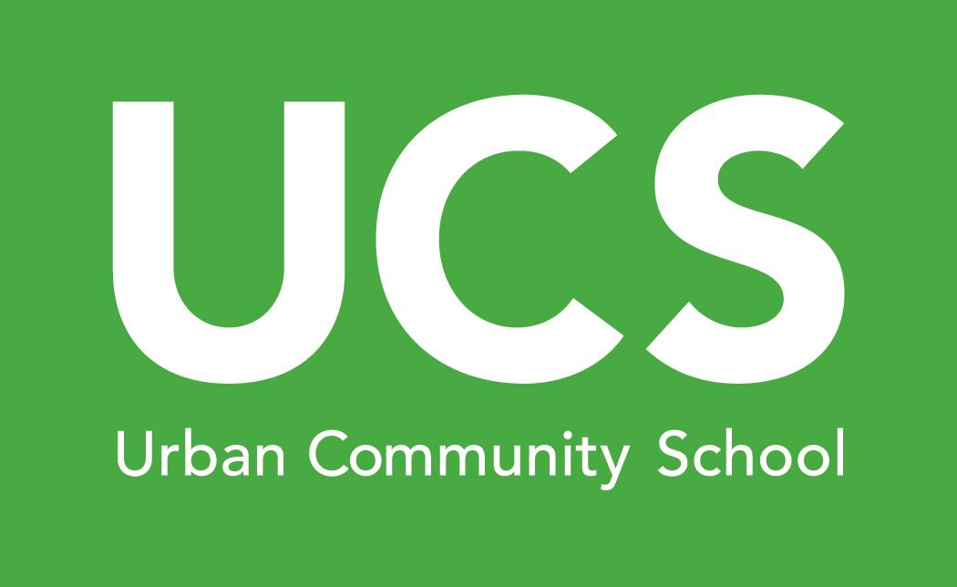
Job Description
Position: Early Childhood Lead Teacher

The Lead Teacher is responsible for the daily operations of the classroom. The Lead Teacher provides a safe, engaging environment for children. The position actively supports and promotes the mission, philosophy, goals, objectives, policies, procedures, and community spirit of the school; models Christian characteristics and behavior in relations with staff, students, parents, and community; and fosters a positive and professional environment by working collaboratively and cooperatively with administrators and staff.

Responsibilities
- Serve in the teaching assignment determined by the Early Childhood Director and performs curricular and extracurricular tasks as assigned.
- Assume direct responsibility for the care and safety of students at all times.
- Responsible for curriculum implementation in the classroom, lesson planning and documentation.
- Ensure the classroom daily schedule includes a balance of both quiet and active play, throughout the day which shall meet intellectual, physical, social, and emotional needs of each child through indoor and outdoor activities.
- Assume extracurricular responsibilities to enhance the educational program or as directed by the Early Childhood Director.
- Maintains required staff-to-child ratios at all times.
- Ensure that all screenings are completed for all students as required.
- Ensure ongoing assessments and evaluations of all students’ progress is conducted and recorded as required.
- Responsible for providing regular communication and feedback to parents/guardians including daily activity reports, progress reports, etc.
- Conduct two (2) parent-teacher conferences per student per school year.
- Keep accurate student records including but not limited to students' academic progress, attendance, behavior, and parental contacts.
- Ensure that the classroom is neat, clean, safe, and in proper working order at all times.
- Complete approved, specialized professional development hours as required by the Ohio Department of Education and Step Up To Quality.
- Participate in staff meetings and trainings as needed.
- Avail himself/herself to staff, students, parents, and administrators as needed.
- Assist in the coordination of students as they transition into a new classroom.
- Report and record any signs of illness or injury and completes incident reports as required.
- Report any suspicion of child abuse, neglect, or endangering to the Cuyahoga County Children and Family Services ((216) 696-KIDS) and the Early Childhood Director immediately, completes and submits necessary paperwork.
- Performs other duties as assigned.

Qualifications
- Bachelor’s degree in child development or early childhood education (or other approved related field); appropriate teaching license preferred.
- Must maintain CPR, First Aid, Communication Disease and Child Abuse Recognition & Prevention certifications.
- Detail oriented with excellent organizational and time management skills.
- Computer abilities and proficiency in databases, word-processing, spreadsheets and learning new software. Appropriate technical skills, including previous use of the following: Microsoft Word, Excel; Database; Internet, E-mail, Desktop publishing, fax, copier, printer, scanner.
- Excellent communications skills; verbal, written, interpersonal.
- Service oriented with ability to effectively interact with students, faculty and administrators.
- Ability to work with confidential information.
- Resourceful with ability to work independently.
- Willingness to participate in skills enhancements and professional development.
- Ability to work well under time demands and to perform multiple tasks.
- Must be able to actively interact with young children by having good dexterity with ability to lift up to 40 pounds, push, pull, carry, climb, balance and kneel and the ability to sit, stand, walk, bend, and squat.
- Candidate for employment must be examined by a licensed physician, physician's assistant, advanced practice nurse, or certified nurse practitioner within twelve months prior to the first day of employment.
- Candidate for employment is subject to a complete BCI and FBI criminal background check.

To Apply
If you are interested in learning more about and/or applying for any of these roles, please contact Debbie LiBran at dlibran@urbancommunityschool.org.

Learn More
urbancommunityschool.org

